LAB 3
EXERCISE 1
File: Student.java
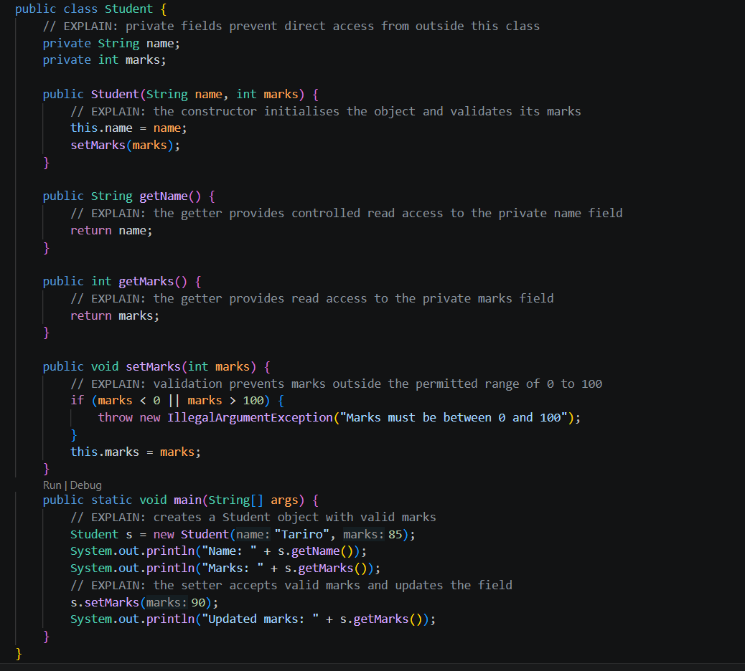

Output:
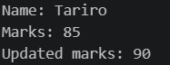

EXERCISE 2
File: Student.java - getGrade()

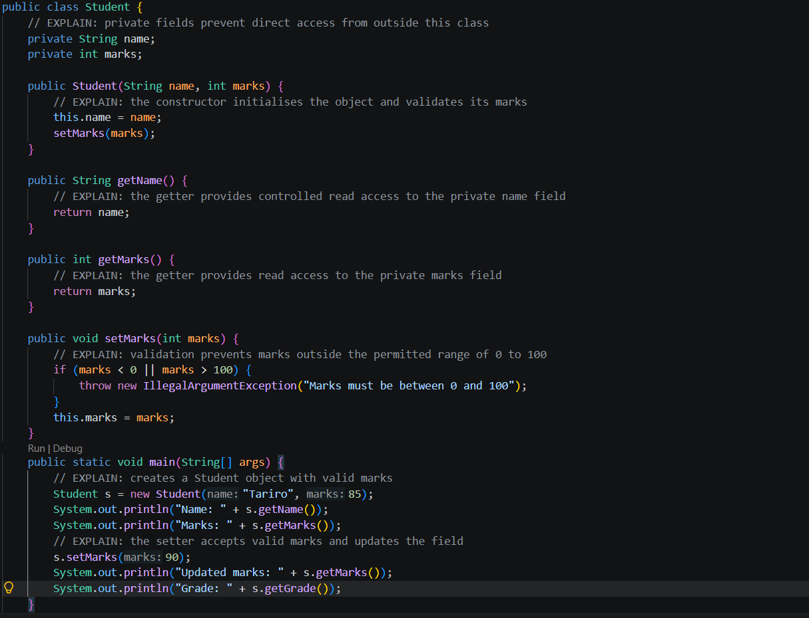
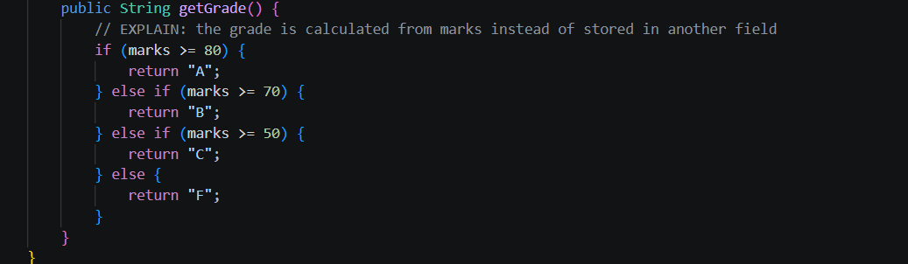

Output:
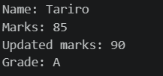

Grade now appears

EXERCISE 3
File: BankAccount.java
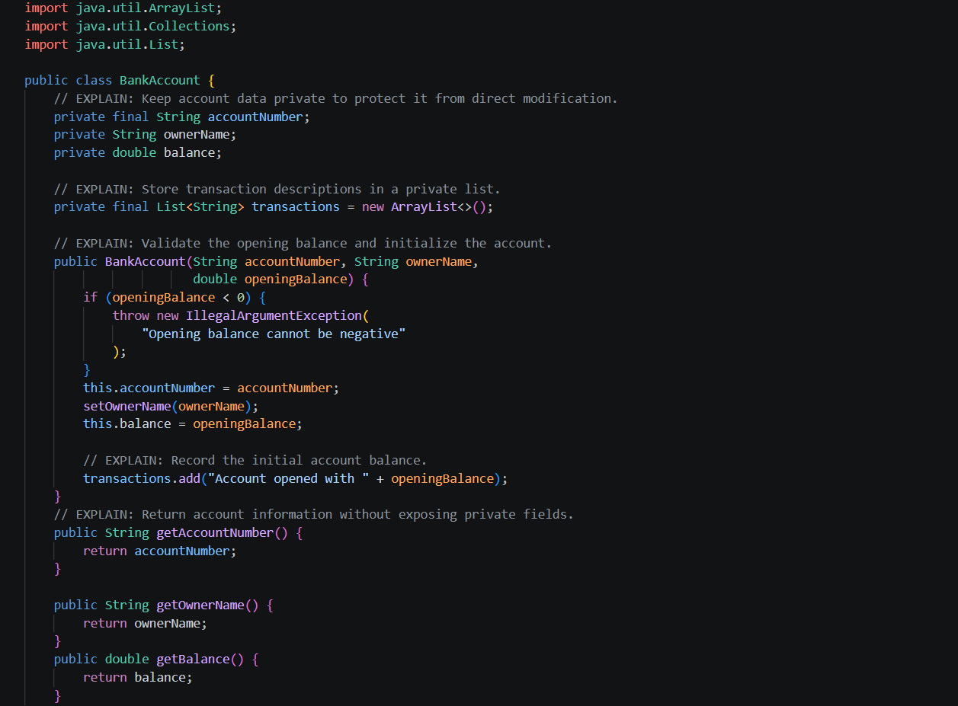
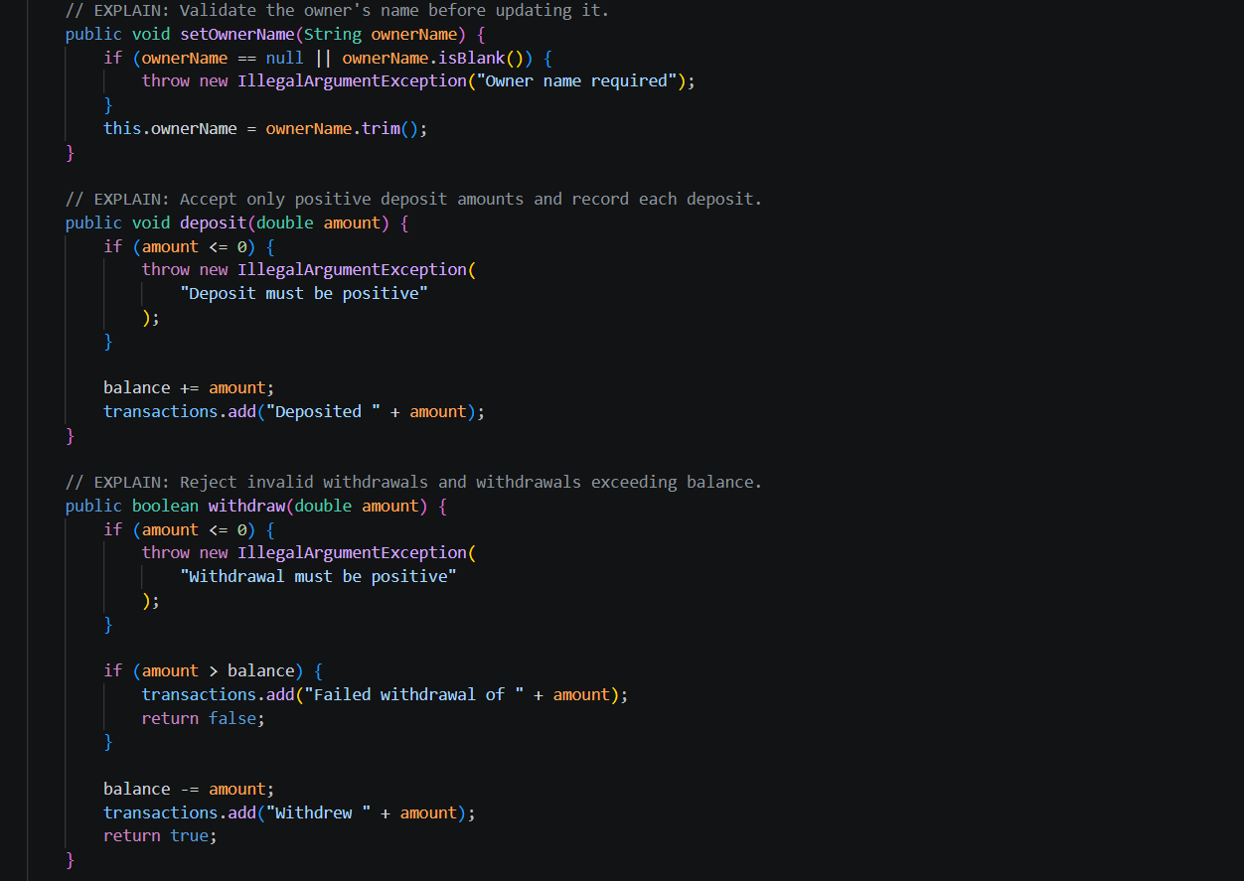
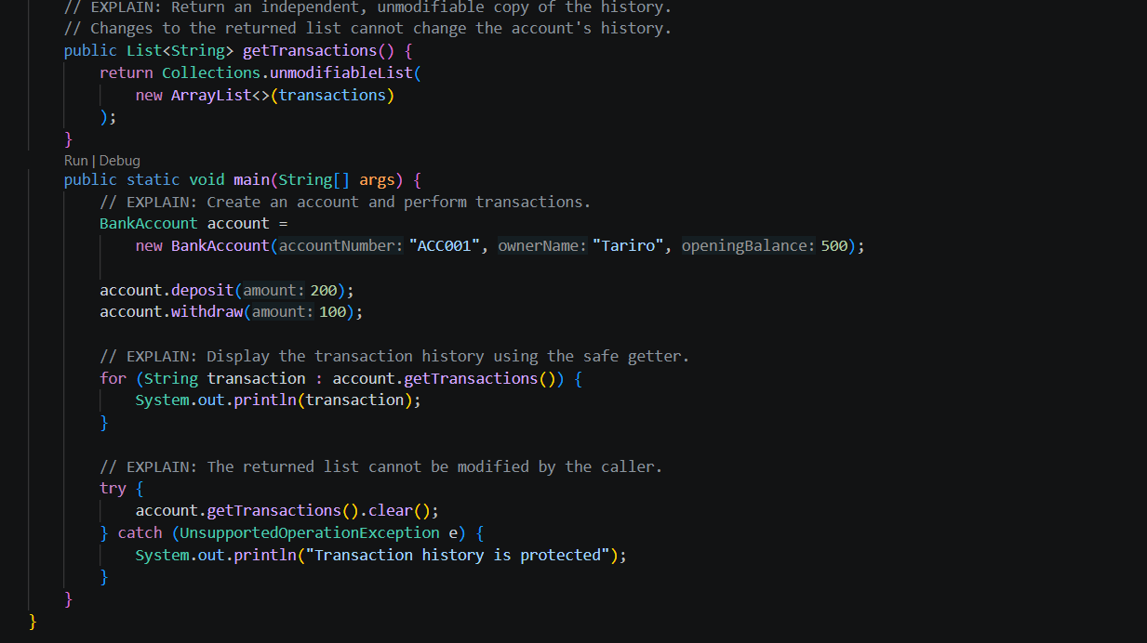

Output:
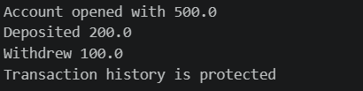

EXERCISE 4
File: ImmutablePerson.java
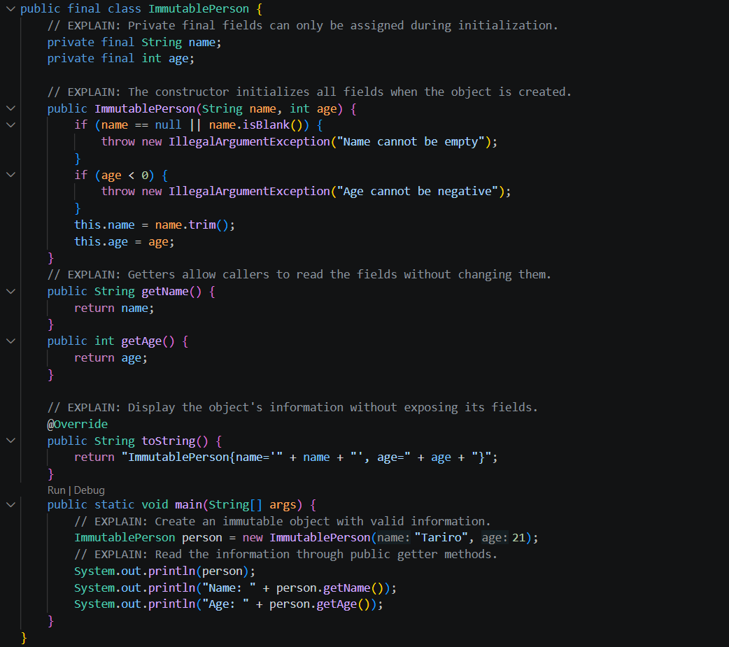
Output:
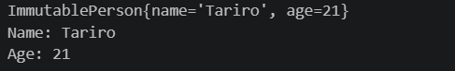

Design choices
- final class: prevents other classes from extending it and introducing mutable behaviour.
- private final fields: prevents direct outside access and reassignment after initialization.
- Constructor validation: prevents creating an object with invalid information.
- No setters: prevents changing the object's state after construction.
- Getters: allow controlled read-only access to the information.
EXERCISE 5
File: Temperature.java

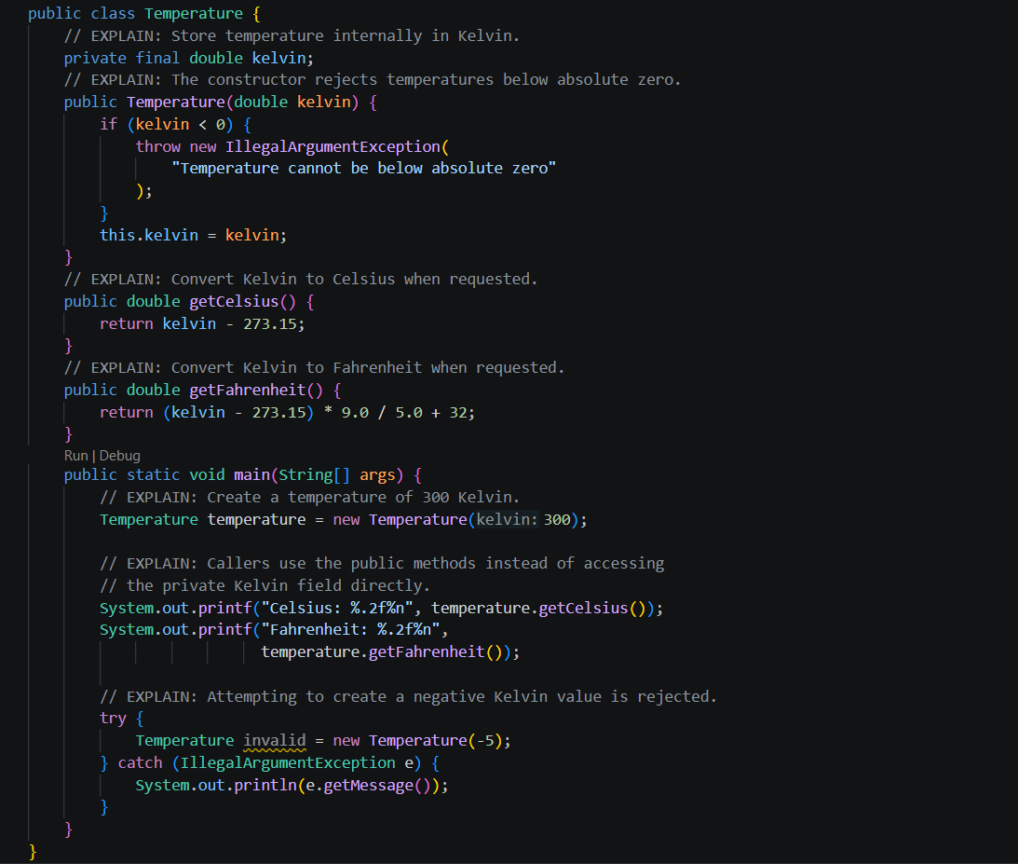

Output:
